Attendance Checker for Students through WI-FI Network

Earl Austin A. Zuñiga
CSIT Depart,emt
Bicol University
Legazpi City, Philippines
earlaustinavilazuniga@gmail.com
Dr. Benedicto Balilo
CSIT Depart,emt
Bicol University
Legazpi City, Philippines
jrbalilo@yahoo.com

Abstract—The attendance tracking using the traditional approach is time consuming because of its long process. Students needs to form a queue in order to sign the attendance sheet. It disturbs the professor during class session. In this modern time, technology is continuously evolving. It gives us a lot of opportunity to make all things easier. Managing attendance through WI-FI network provides an easy way in monitoring attendance of students. Technology such as gadgets are very common nowadays. With the help of gadgets enabled WIFI, marking attendance record can be very easy and saves time for the students and professors. In this proposed system, the researcher offers a way to make attendance checking efficient and easy to manage. The proposed system will be Web-Based because it increases efficiency, flexibility, access and availability to users. With the use of wireless networks and gadgets such as laptops and mobiles, the students can mark the attendance record without having to form a queue. Communication between professors and student’s guardian is important, being notified about the attendance record helps the student’s guardian to monitor the presence of the students. The proposed system will be easy to use and manage.
Keywords—attendance tracking, proposed system, Wi-Fi

Introduction
School is where students learn something new and hone their skills. It is a very common place in which students has an opportunity to obtain new knowledge and change their future. During class hours, the school will surely need to know whether a student came to class or not. It is a way to monitor the performance of students. For the above reason, systems for tracking attendance was created. It helps detect the presence of a student during class hours. The traditional approach for monitoring attendance is attendance card system for which professors needs to check each student in a class who came to school and log book system where students are required to sign their signature. This kind of system is very simple but not efficient. One of the main reason why this kind of system is atrocious is time consuming. Students and professors needs to form a queue in order to check the attendance paper. Another reason is the school needs keep their attendance records in paper. We live in an era where records need to be computerized in order to manage it efficiently. Evolution of technology offers us a lot of opportunity to make things easier. In this paper, the researcher introduces a proposed system, an efficient and smart way in handling monitoring of attendance that will benefit students and professors. This system makes use of wireless network to communicate to database that holds the records of attendance. Accessing and updating records requires a good security and protection in order to avoid cyber-attack. Encryption algorithms is also needed in order to protect sensitive data that travels through network. Wireless network enabled Gadgets like laptop and cellphone is very common to students in this century. It can be used in the proposed system in order for the students to mark attendance record simultaneously without having to create a queue in order to sign the attendance paper. In order to avoid cheating of marking attendance, the system will generate a unique set of strings in each class session that will be used by students to mark their attendance. The system also has a feature in which authorized person can view and manage attendance record of students. It offers a lot of advantages in terms of efficiency, management and time. The system will surely help schools, specially the professors and countries all around the world.

RELATED WORKS
This section is review of few related systems and their different methods in recording attendance.

Monitoring Attendance using MAC address approach uses devices in order to identify student’s identity. MAC addresses are 6-byte (48-bits) in length, and are written in MM:MM:MM:SS:SS:SS format. Every device has a unique MAC address. It referred to as hardware or physical address of a device. This approach identifies students based on registered devices and automatically mark their attendance record. The disadvantage of this method is when a student forgot or lost his device. ²

Another method used in monitoring attendance is by using facial recognition. A facial recognition system is a technology capable of identifying or verifying a person from a digital image or a video frame from a video source. It offers an accurate and efficient way in checking attendance of students but it has many issues and lacks support of system. ⁴

Biometric system approach captures your unique biological/physical feature such as your hand or finger print, iris pattern and sometimes even your voice as a record for identity verification and allows you to perform something that you are authorized to do. It is widely used in companies for recording attendance.¹

Near-field communication (NFC) is a set of communication protocols that enable two electronic devices to communicate to each other. The most common device that has this feature is mobile phones. This kind of method is not widely used because of its limitation. NFC devices can only communicate if each device is in 4-meter radius. ³

Each system has the same concept of using wireless method. In terms of cost and availability, WIFI method has a clear advantage for it is widely used around school.

SYSTEM ARCHITECTURE

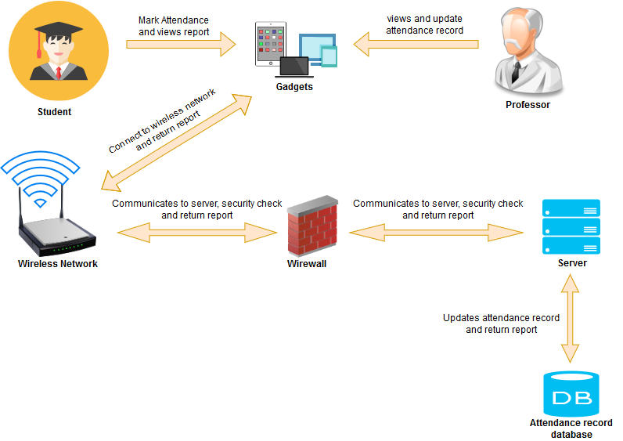.
Fig 1. Proposed System

In the above system architecture of the proposed system, the students and professors are required to connect to WI-FI network of the school in order to communicate to system. Any gadgets that can connect to WI-FI network can be used. Once connected to WI-FI network, students and professors are required to use a browser app in their gadget to access the system. Google Chrome is recommended for this proposed system for chrome has better security and protection. The devices used will pass throught the Firewall of the modem. Students and professors can now manage and mark the attendance record by visiting the system’s web page.

PROPOSED IMPLEMENTATION
This proposed system can work in any device that supports wireless network.

1 Professor’s Module: This module’s purpose is to insure maintainability, monitoring and control of other modules in Attendance Checker system.
  - Attendance Record Viewer: This allows the professors to view everyday attendance record of the students. It will show the absentees and students who came to class. This module will also show the number of absentees and present in each class, it can be filter by subject, day, month and year.
  - Create Class Session. This module allows the professor to create class session. This represents the school days of the student.
  - Unique Key generator for Attendance Checking: This module’s purpose is to generate a unique key, a set of random strings to be used by students for checking the attendance record.
  - Alert/Warning of Attendance Record: This module will automatically notify students about their attendance record. The Professors can set the limit for students to be allowed to not attend the class. If the number of absentees of a student reached the limit, the student will be notified and will show their attendance record.
  - Reporting of Attendance record to student’s guardian: The main purpose of this module is to notify the student’s guardian about their attendance record. If a student doesn’t attend the class, the system will notify the student’s guardian about the issue. This module will use a third party application to send electronic mails. The recommended application to use is PHPMailer: An add-on application to websites written in PHP language. It will be used to notify the student’s guardian.
  - Adding Student’s information: Professors can add student’s information. It includes name, contact number, guardian’s email, student’s picture and class information. This module can filter students by class.
  - Export Attendance record through excel or PDF form. Exporting attendance record into soft copy gives the professor less effort in managing attendance of students. This module should export attendance record by student or by class.
  - Deleting Attendance Records: This module allows the professors to delete old records that no longer needed. It is a way to clean the system by deleting records of students to give space for the Attendance record database.
  - Notification Module: The main function of this module is to notify the professors about the number of absentees, filling of excuse letter of students and status of systems module.

- Students Module: This module allows the student to view and mark their attendance during class session.
  - Marking of Attendance Record module: Students can mark their attendance record during class session. The student must be able to connect to school’s WI-FI network using their gadgets in order to mark the attendance record. The system will generate a unique key that will serve as a password for checking the attendance.
  - Viewing of Attendance Record: This module allows the student to view their attendance record. It can be filter by class, day, month, year and absentees. It also shows the remaining number that they can absent in the subjects or class.
  - Filing of Excuse letter: If a student can’t attend the class because of an emergency or important matter, the student can file an excuse letter to their professor to consider their reason for not being in the class. The student will be notified if the professor approves his/her request.
  - Notification Module: This module main purpose is to notify students about their attendance record, updates on filling of excuse letter and their status.
  - Profile Module: A module that allows student to include their personal information like Identification Picture, age, email address and other things that can describe the student.

- Admin Module: Admin module controls and manages all the important data and features that the system has.
  - Database Control: This function allows the admin to control all the data stored in the database. The admin can delete, update and add data. The main purpose of this module is to insure maintainability and confidentiality of the data stored in the system.
  - System Setting: The admin can change the design of the system such as logo, theme and system title. It offers flexibility of the system based on the user’s needs.
  - System Monitoring using logs: every activity that runs through the system will be saved as logs. By the use of logs, the admin can monitor the system’s activity and error occurred during the use of the system.
  - Resetting Account’s password: this module will help user to recover their account when they forgot their password. The user will have to pass some security test to prove that he/she is the owner of the account. Resetting password using email is one of the convenient way in implementing it.
- System Module: Other software that the system uses.
  - Email Module: This module allows the proposed system to send emails to student’s guardian regarding the student’s attendance record. The recommended software for this system is PHPMailer: a code library to send emails safely and easily via PHP code from a web server.
  - Server Module: It is where the database and the system is stored. The recommended software for this system is apache: a free and open source cross-platform web server.
  - Database module: This module’s purpose is to manage data in the database. The recommended software for this system is MySQL: an open source relational database management system.
  - Encryption: hashing passwords Module: A module that encrypts sensitive data of professors and students such as passwords. The recommended algorithm is PBKDF2 encryption: an algorithm which is used to derive keys.
- System Requirements
Operation System: any system that has web browser
Software: WI-FI Network
Database: MySQL database server

CONCLUSION

Attendance is used to measure the performance and presence of a student. Making a complete efficient system for attendance checking gives the professor and school less time in managing attendance. This proposed system offers easy control, reliability and accessibility. Professor and student’s guardian can see the student’s attendance record anytime. Implementing this proposed system can reduce the dependencies on natural resources like papers. It also provides a way to communicate between professors and student’s guardian regarding the attendance record. The proposed system enables student to send excuse letter to professor if they’re unable to attend class. Overall, this system will surely help the community, specially, for the schools and universities around the globe.

Acknowledgment

I am extremely thankful and pay my gratitude to my project guide Dr. Benedicto Balilo for his valuable guidance and support on completion of this project work. I would also like to thank my friends and colleagues for their motivation and support.

Finally, I wish to thank my parents for their support and encouragement throughout my study.

References

- Dhiman Kumar Sarker, Nafize Ishtiaque Hossain, Insan Arafat Jamil, "Design and implementation of smart attendance management system using multiple step authentication", Computational Intelligence (IWCI) International Workshop on, pp. 91-95, 2016.
- Dr. Sreeja Mole S. Sujatha.k, Kaviyaraj R and Susmitha U,2018 “smart attendance monitoring system using wifi and mac adddress,” http://troindia.in/journal/ijcesr/vol5iss2part2/6-8.pdf.
- Mohandes and Mohamed A. 2017, “Class Attendance Management System Using NFC Mobile Devices,” . Intelligent Automation & Soft Computing.https://doi.org/10.1080/10798587.2016.1204749
- Rajwant Kaur, Dolly Sharma, Amit Verma, "An advance 2D face recognition by feature extraction (ICA) and optimize multilayer architecture", Signal Processing Computing and Control (ISPCC) 2017 4th International Conference on, pp. 122-129, 2017.

